**6.RESTRICTING AND SORTING DATA**

**NAME: B ELUMALAI**

**ROLL NO: 230701084**

**Find the Solution for the following:**

1. **Create a query to display the last name and salary of employees earning more than 12000.**

**select Last_name, salary from Employ where salary>12000;**

**output**



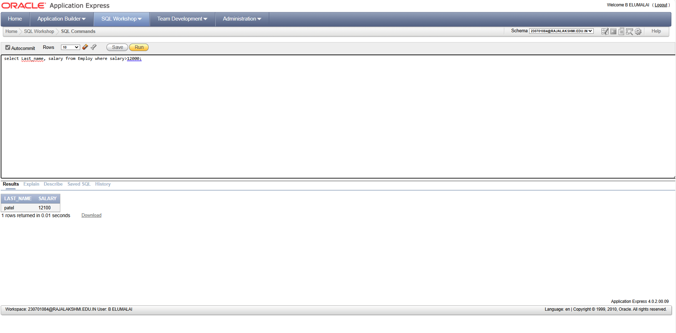

1. **Create a query to display the employee last name and department number for employee number 176.**

**select Last_name,department_id from Employ where employee_id=176;**

**output**

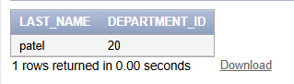

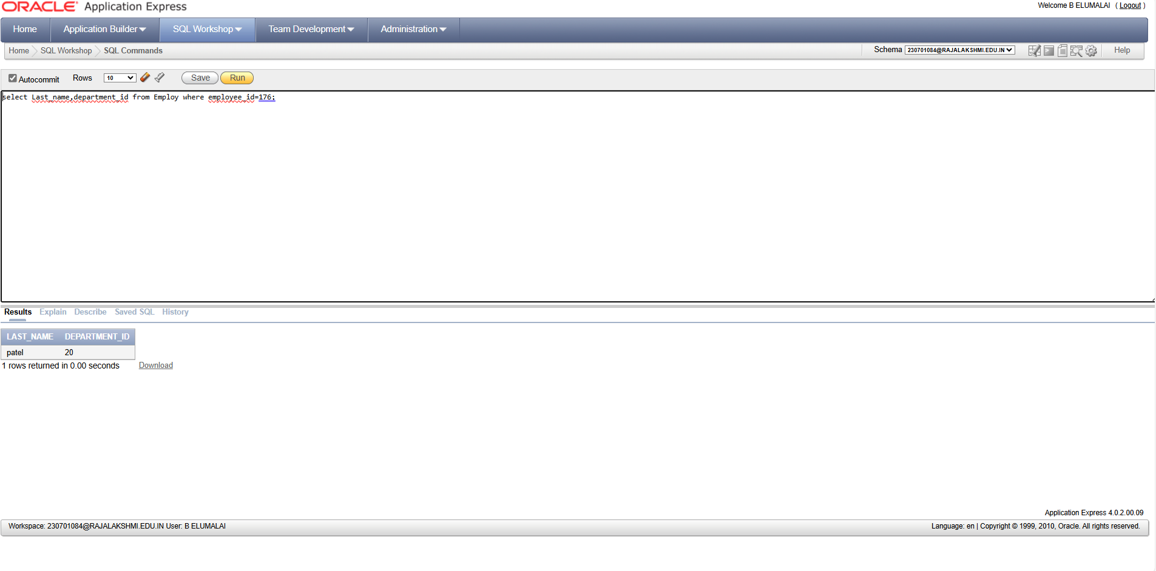

**3. Create a query to display the last name and salary of employees whose salary is not in the**

**range of 5000 and 12000. (hints: not between )**

**select Last_name,salary from Employ where salary not between 5000 and 12000;**

**output**

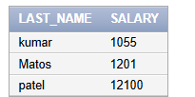

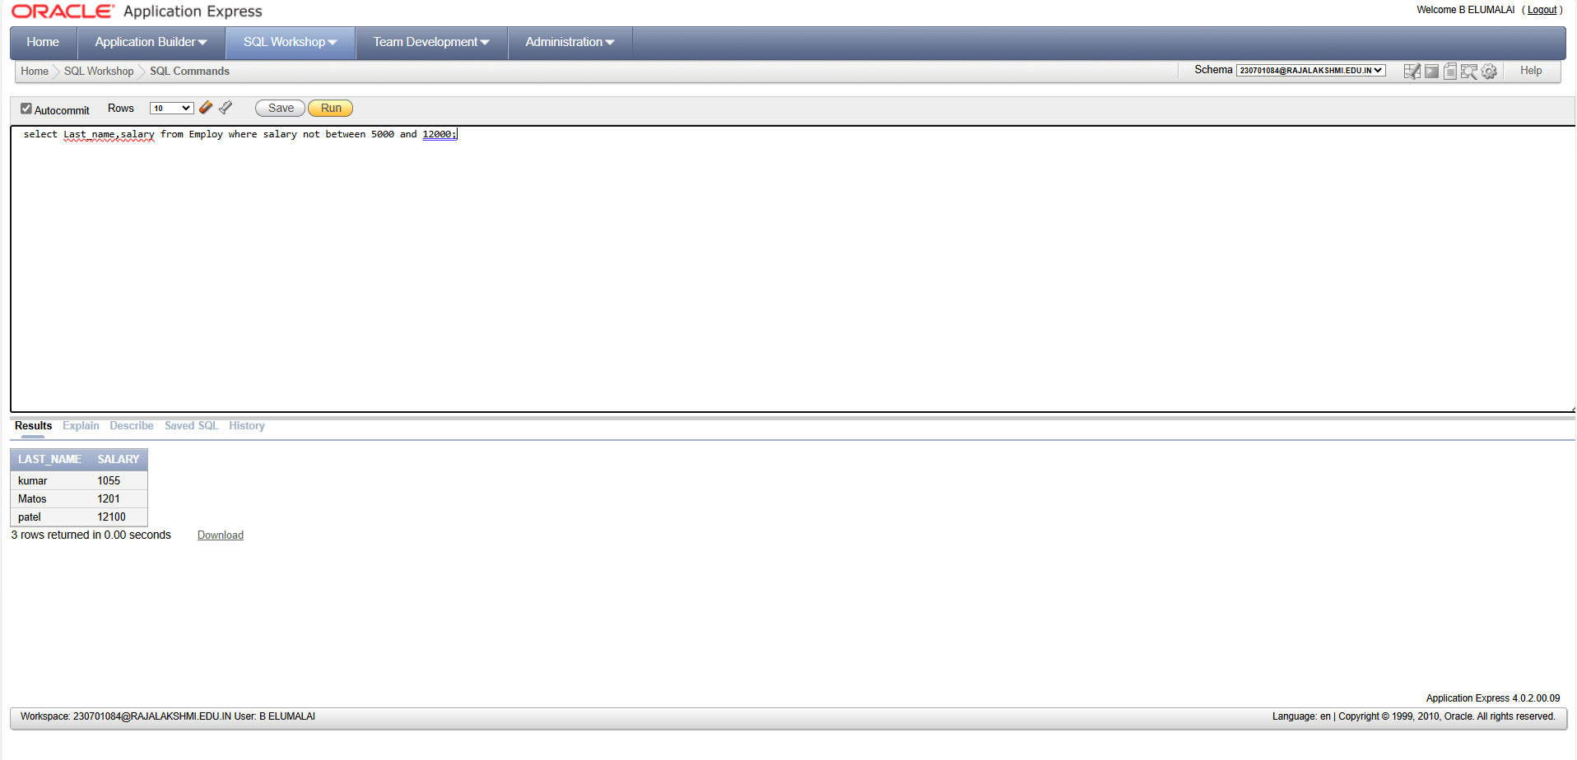

**4. Display the employee last name, job ID, and start date of employees hired between**

**February 20,1998 and May 1,1998.order the query in ascending order by start date.(hints:**

**between)**

**select Last_name,job_id,hire_date from Employ where hire_date between '12-20-1998' and '5-12-1998' order by hire_date;**

**output**

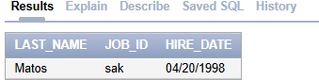

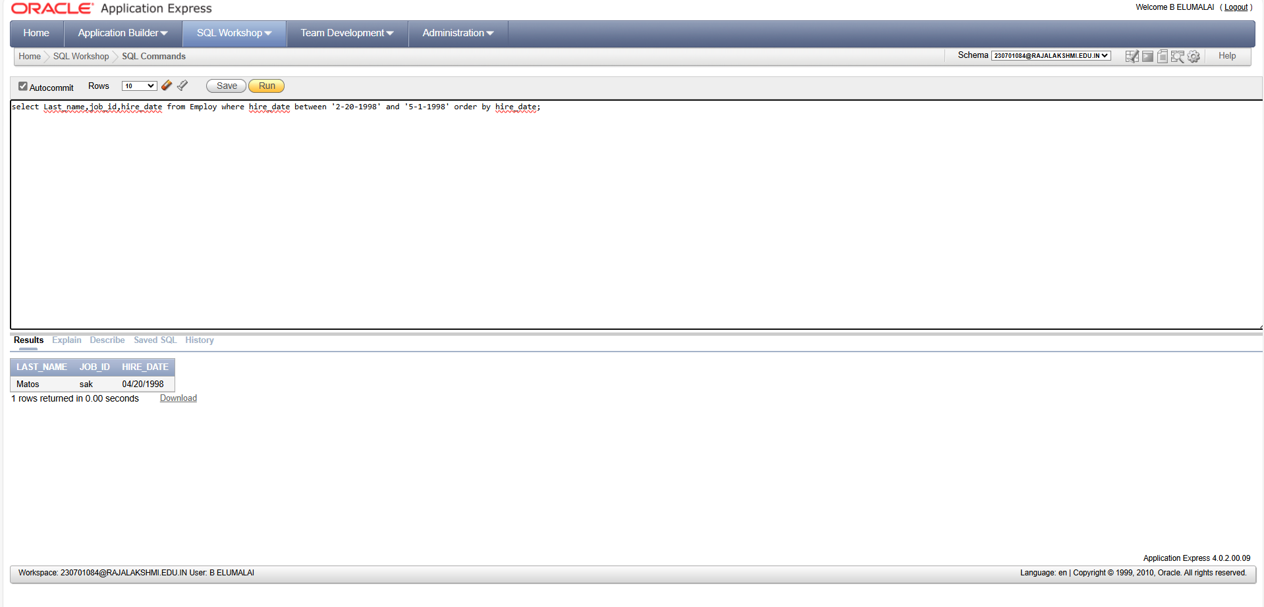

**5. Display the last name and department number of all employees in departments 20 and 50**

**in alphabetical order by name.(hints: in, orderby)**

**select last_name,department_id from Employ where department_id in(50,20) order by last_name;**

**output**

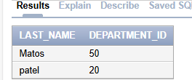

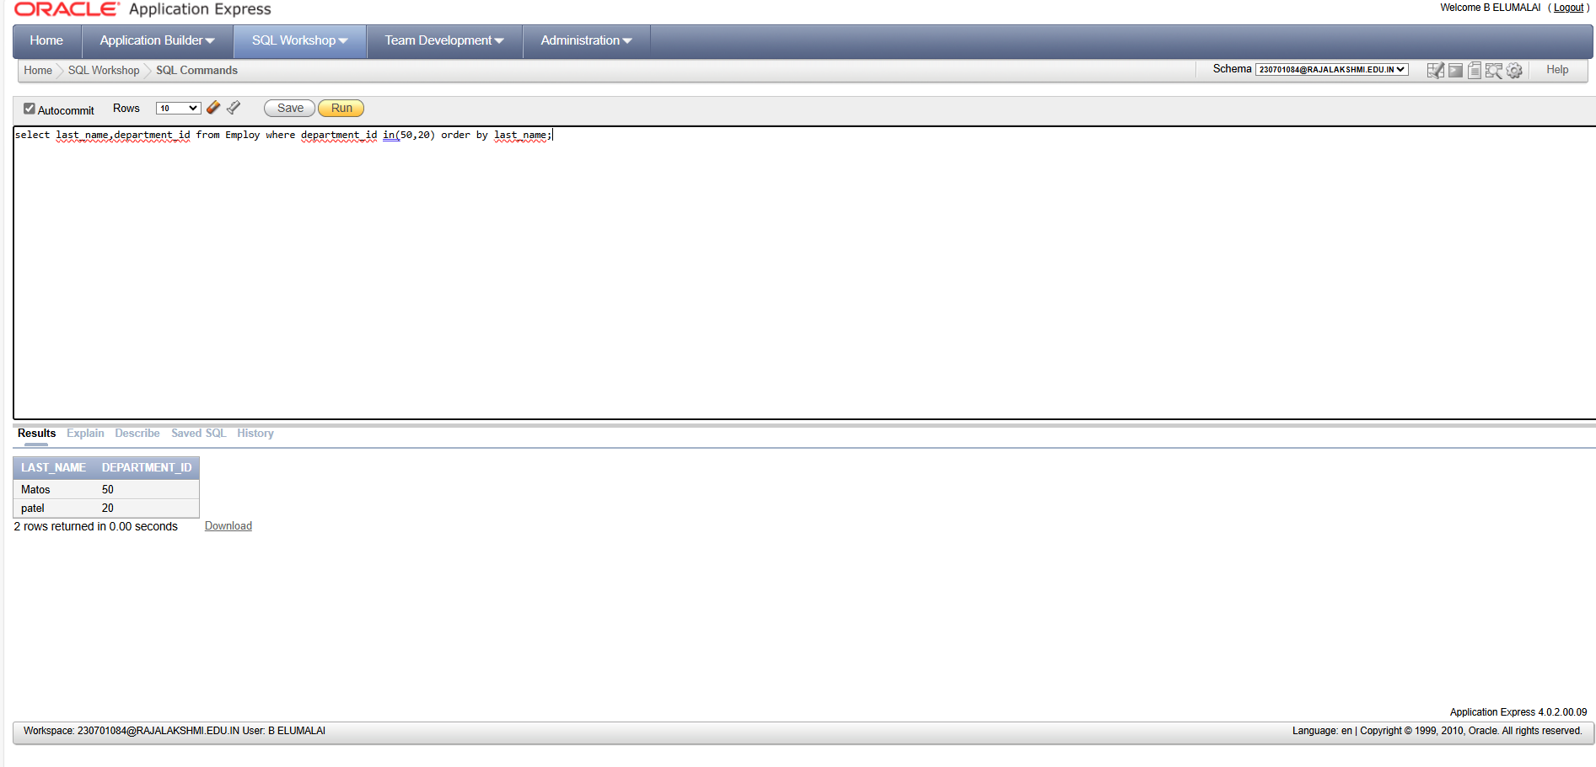

**6. Display the last name and salary of all employees who earn between 5000 and 12000**

**and are in departments 20 and 50 in alphabetical order by name. Label the columns**

**EMPLOYEE, MONTHLY SALARY respectively.(hints: between, in)**

**select last_name, salary from employ where (salary between 5000 and 12000 and department_id in (20,50)) order by last_name;**

**output**

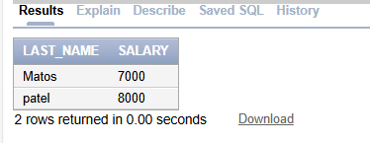

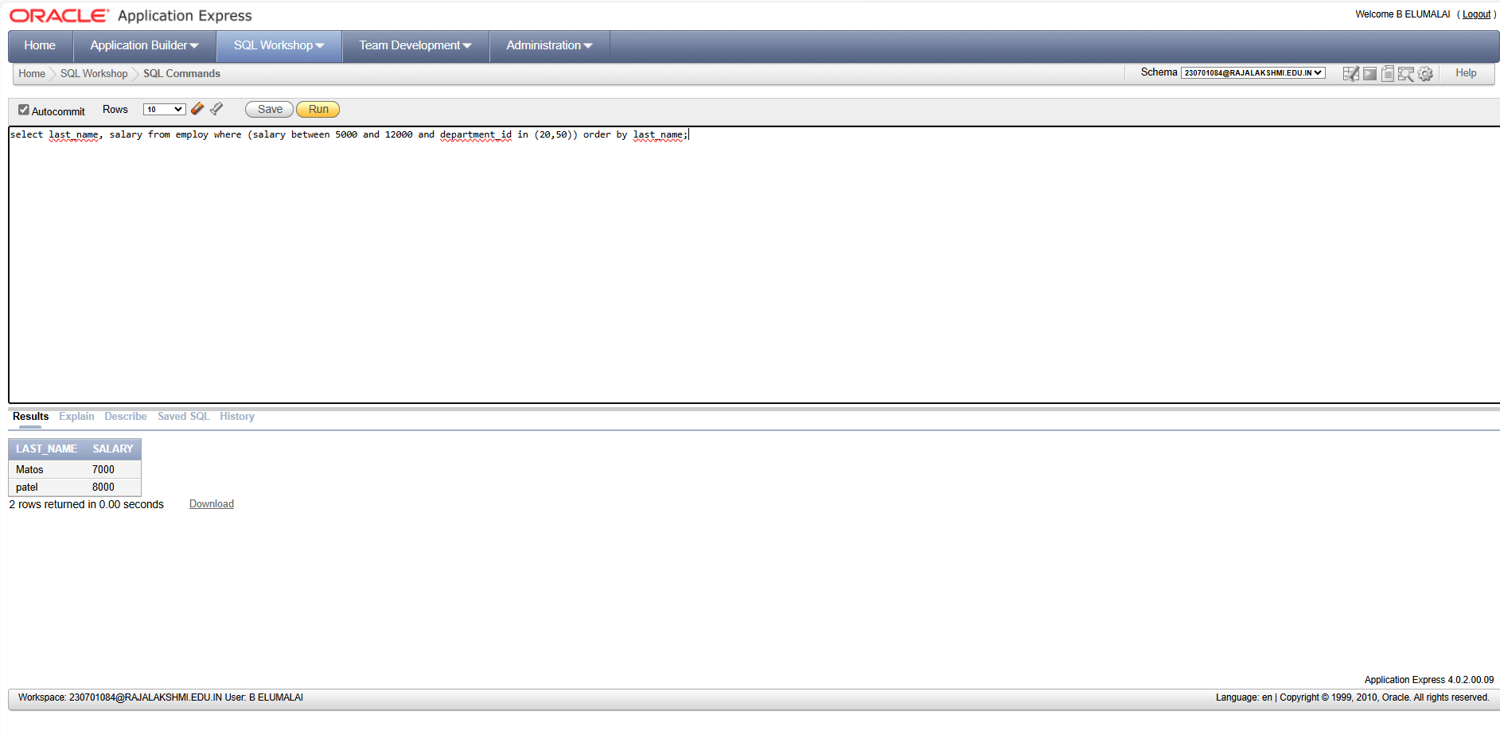

**7. Display the last name and hire date of every employee who was hired in 1994.(hints: like)**

**select last_name,hire_date from employ where hire_date like '% 1994';**

**output**

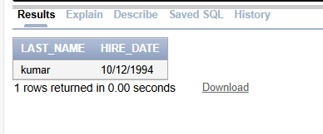

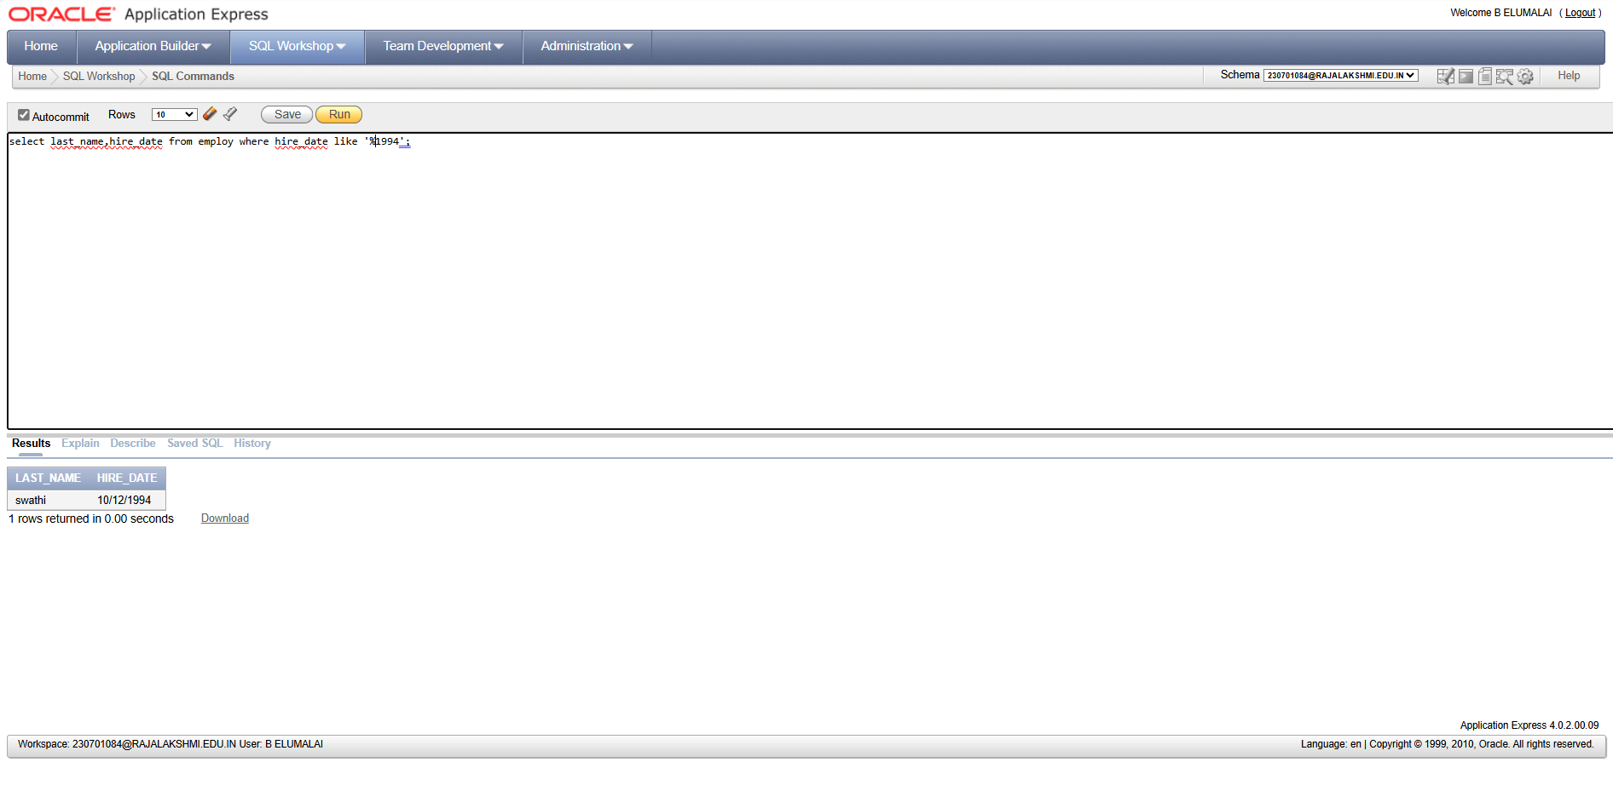

**8. Display the last name and job title of all employees who do not have a manager.(hints: is**

**null)**

**select last_name,job_title from employ where manager_id is null;**

**output**

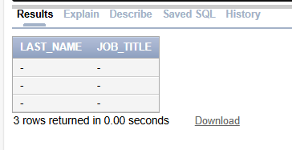

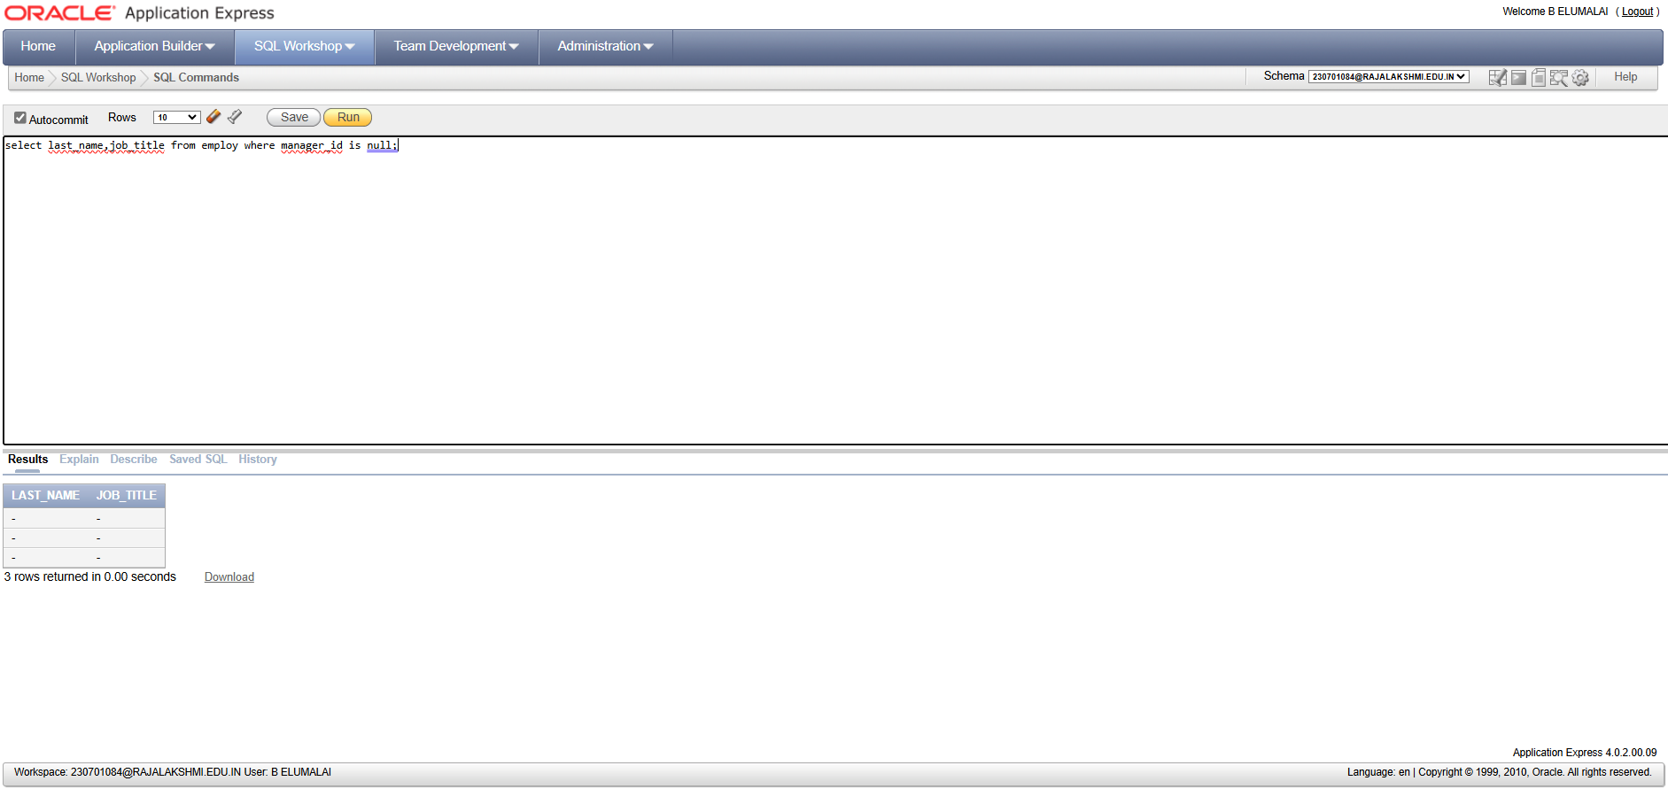

**9. Display the last name, salary, and commission for all employees who earn commissions.**

**Sort data in descending order of salary and commissions.(hints: is not nul,orderby)**

**select last_name,salary,commission_pct from employ where commission_pct is not null order by salary,commission_pct;**

**output**

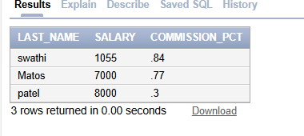

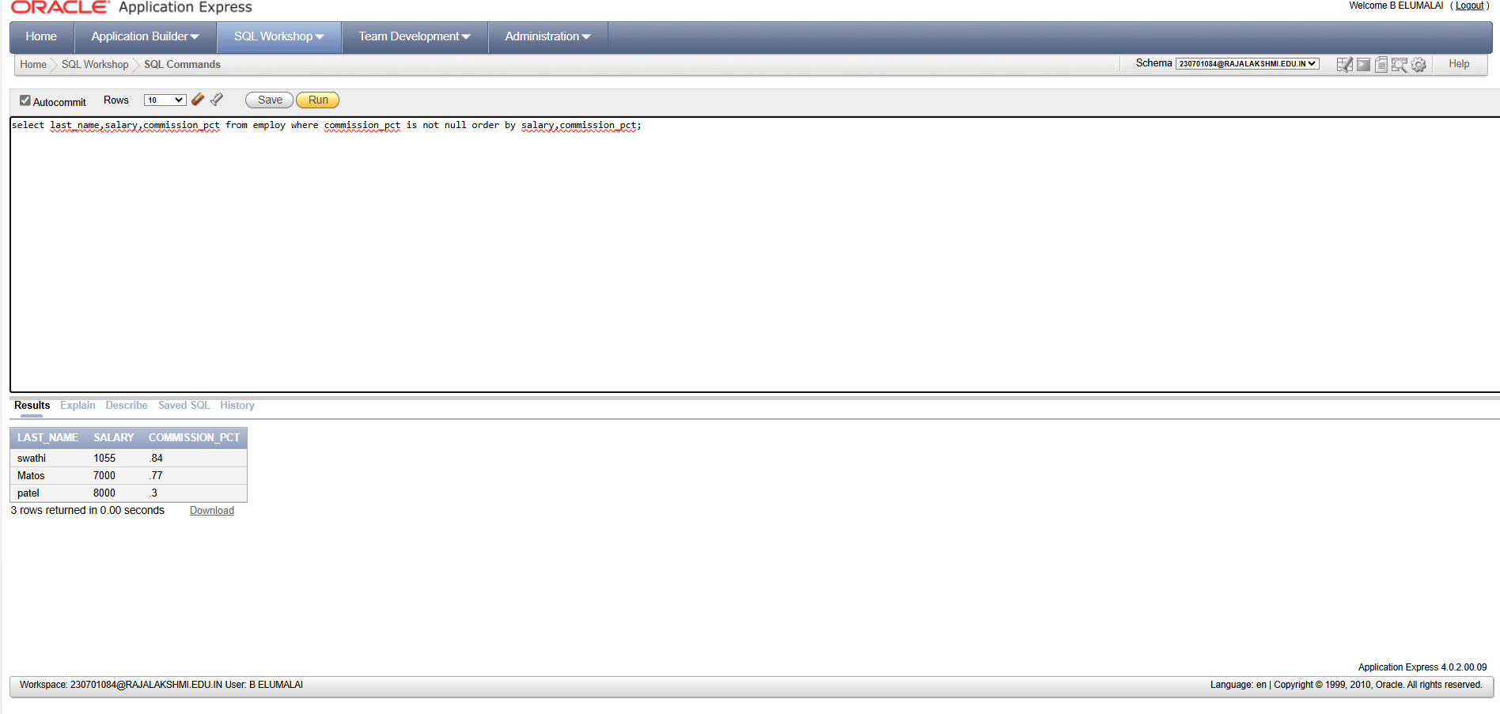

**10. Display the last name of all employees where the third letter of the name is a.(hints:like)**

**select last_name from employ where last_name like'__a%';**

**output**

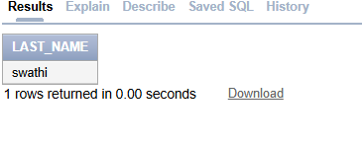

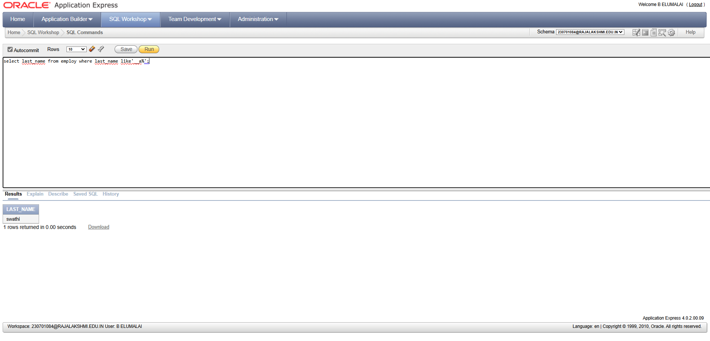

**11. Display the last name of all employees who have an a and an e in their last name.(hints:**

**like)**

**SELECT last_name FROM employ WHERE last_name LIKE '%a%' AND last_name LIKE '%e%';**

**Output**



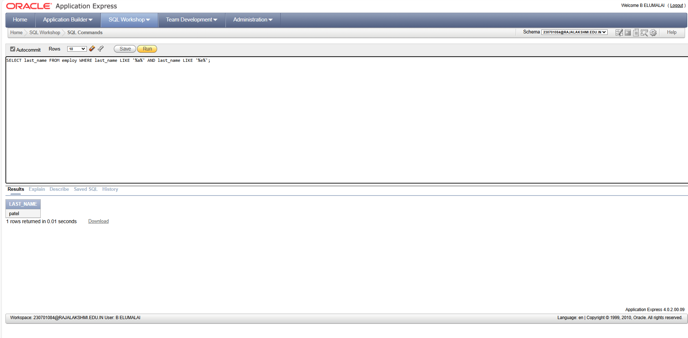

**12. Display the last name and job and salary for all employees whose job is sales**

**representative or stock clerk and whose salary is not equal to 2500 ,3500 or 7000.(hints:in,not in)**

**select Last_name,job_title,salary from employ where Job_title in('sales representative','stock clerk') and salary not in(2500,3500,7000);**

**OUTPUT**

